[Date]

12ShiroY

AI Home System Linked To Scalextric Track

OCR Computer Science Project

Table of Contents

Analysis 1

The Problem 1

The Stakeholders 1

Existing Solutions 1

The Essential Features 1

Potential Limitations 2

Hardware and Software Requirements 2

Success Criteria 2

Design 4

Decomposition 4

Structure 4

Algorithms 4

Usability 4

Variables, Data Structures and Classes 4

Iterative Development 4

Further Data 4

Developing 4

Iterative Developments 4

Prototypes 4

Structures 4

Examples of Code (Annotated) 4

Variable Names 4

Validations 4

Review 4

Evaluation 4

Success Criteria 4

Development In Future 4

Future Improvements 4

Usability 4

Bibliography 4

# Analysis

## The Problem

Above all preference, I would like to create an AI with the ability to beat a human in a race (Scalextric). I will achieve this via computer vision and human learning. The AI should be able to find the optimal current at each stage of the track in order to achieve the best possible time to finish a lap. I will do this by linking a Scalextric track to a voltmeter and ammeter which will also be linked to a raspberry pi, monitoring the electrical current to output into the Scalextric remote. The majority of the programming will be done on a raspberry pi using python as this is seen as the best language to code AI in. The AI will be able to locate its position on the track via computer vision. It will be able to do this due to an input from a top down camera, allowing it to understand the view of the whole track and its position upon it. This camera will also be linked to the raspberry pi. If I have time and everything else so far has proven to be effective, I would like to link this project to a google AIY kit which uses a basic vocal home system to complete commands. This could allow the project to be much easier to use for the client.

## The Stakeholders 1.1

Currently, my stake holders are people who are interested in Scalextric, who could play on their own and try to race against the AI however, in the future this could be implemented in the development of driverless cars. This could make life much easier and safer in the future as this could reduce the amount of car crashes every year due to lack of potential for human error while driving. The age range for this product is for ages between 6 and 18.

My main stakeholder is Tom Smith, who is a 15 year old male, with an interest in both computer science and Scalextric. The problem he faces is that he isn’t challenged by anyone else who plays against him, as he is significantly talented at Scalextric. He is extremely interested in having the opportunity to have an opponent which has significant potential to beat him. This would be better than any existing solutions as they do not have truly difficult AI’s with real potential of being a challenging opponent. The convenience of having a stakeholder like Tom is that he can provide very quick and accurate feedback frequently, allowing me to understand the possibility for improvement. This will allow me to build upon multiple prototypes and have a relevant member of the public to test my product from a separate view to me. This could allow me to make my hardware and/or software more ergonomic to the user.

This was the response from my stakeholder, Tom Smith, when I asked him 10 questions about the project.

1. What age range do you think this project is suitable for?  
   I'd like it to be suitable for 15-16 year olds like me. Either gender
2. Do you find anything confusing about the idea for the project?  
   No.
3. Do you find anything confusing about the hardware?  
   No
4. Do you find anything confusing about the software?  
   I'm not sure yet what the software would run on - that's for you to decide. As long as it can control a car I'm not fussed how it works
5. Would you buy this product from a store?  
   Yeah, if it was relatively cheap and looked high quality. It'd be fun for parties or events
6. What would you want this product to be able to do?  
   It must be able to control a car, so I guess it should sense where the car is on the track and be able to change the speed, aiming to get around the track as quickly as possible without falling off. If it could learn from its mistakes that'd be great.
7. Do you prefer the idea of this product more interesting or entertaining than other products such as Real FX Racing?  
   I don't know much about REAL FX Racing, but if your idea could be simpler to use and cheaper to buy that'd be great.
8. What would be the ideal shape and size of the Scalextric track?  
   A simple figure of 8 would be ideal - that's the most common shape.
9. How quickly do you reckon the AI will be able to complete the track (your suggested shape)?  
   Not sure really, sorry.
10. Would you like to use a voice operated system for this product or not?  
    That would be awesome!

## Existing Solutions 1.1

Real FX Racing have already implemented the idea of AI in toy racing cars in one of their latest products which similarly uses computer vision for the car to be able to drive by itself (<https://www.youtube.com/watch?v=I6qGNQfZiLE> ).

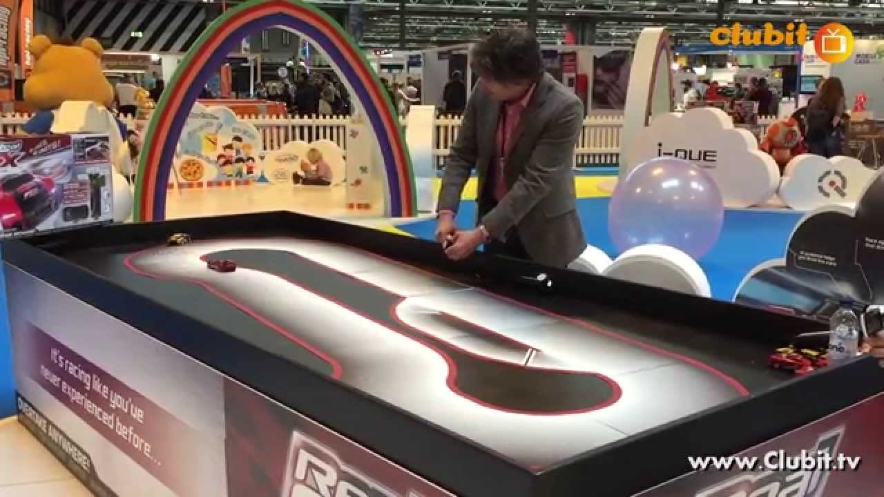 Their product targets the idea that you can have your best lap time mimicked by another car using the saved movements which you have made (acting as a ghost trail of your quickest lap). This simply records every input which you make while controlling the car during your quickest lap. This is an interesting idea and is actually quite a good solution for the existing problem. However, the idea that AI could be used to drive on a Scalextric track is much more complex as there is a higher skillset for one of these tracks than there is for something like a Real FX Racing track. The problem here is that they use closed source software which you cannot access even if you buy the product, meaning that I cannot see what makes their product the most efficient.

## The Essential Features 1.1

The essential features of this project consist of an AI which races against a human opponent on command and easy to use software which is gender neutral. This is the heart of the project so without this being achieved, the whole idea collapses. I will try to focus my attention on these features in order to complete my task as soon as possible.

## Potential Limitations 1.1

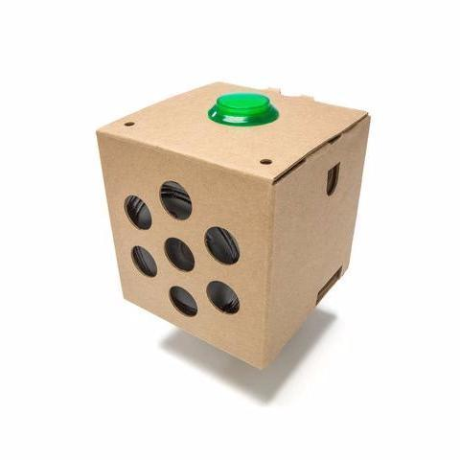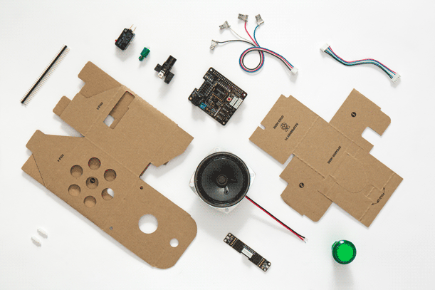The price of this project is a major limitation as in the worst case scenario; I may have to spend over £100 on this project. However, I will try to avoid this by using second hand items such as a Scalextric track and self-made alternate hardware such as a homemade Google AIY kit. Another limitation is the complexity of the coding necessary to complete this task. This project requires an extremely high knowledge of python which I do not yet possess and this will mean that I will have to put in extra time at home to build my knowledge of this. Another possible limitation for the project would be if there was a flaw with the hardware (e.g. response time or frame rate of camera, faulty pins on the raspberry pi etc.). This could potentially limit the processing speed and overall, limit the potential speed of the AI. I will try to avoid this by keeping track of the computer usage throughout the evolution of the project, making sure nothing gets overloaded or potentially break, which could spawn other limitations such as price instantly.

## Hardware and Software Requirements 1.1

|  |  |  |
| --- | --- | --- |
| Number of Requirement | Hardware Requirements | Software Requirements |
|  | A raspberry pi – most likely a raspberry Pi zero as I am working on a limited budget but ideally, a Raspberry Pi 3 B+, as it has a variety of essential upgrades in comparison to the cheaper alternative. I would also need to buy essential parts to use the raspberry pi such as their power block, a micro SD card and potentially, a case (to prevent any damage being done to the raspberry pi). The features of the Pi Zero: BCM 2835 SOC @ 1GHz, 512MB of RAM, micro-SD, mini-HDMI, micro-B USB for data, micro-B USB for power, CSI camera connector (needs adaptor cable for an extra £5), Unpopulated 40-pin GPIO connector, Compatible with existing HAT add-ons, Dimensions: 65mm x 30mm x 5mm  The Features of the Pi B+: 1.4GHz 64-bit quad-core ARM Cortex-A53 CPU (BCM2837), 1GB RAM (LPDDR2 SDRAM), On-board wireless LAN - dual-band 802.11 b/g/n/ac (CYW43455), On-board Bluetooth 4.2 HS low-energy (BLE) (CYW43455), 4 x USB 2.0 ports, 300Mbit/s ethernet, 40 GPIO pins, Full size HDMI 1.3a port, Combined 3.5mm analog audio and composite video jack, Camera interface (CSI), Display interface (DSI), microSD slot, VideoCore IV multimedia/3D graphics core @ 400MHz/300MHz | AI – an evolutionary AI which learns how to move the car around the track, when it crosses the finish line and how to decrease the time taken to complete a lap. This AI will do this using computer vision and measuring the outputs via ammeter and voltmeter. |
|  | (possibly) Voice Recognition kit for Google Cloud Speech – this consists of 170 tie point mini breadboard, 10 male to male 20cm breadboard cables, MAX9812 amplified microphone, NPN transistor, red LED and two resistors (1k and 220ohm). | A UI – easy to use UI (ideally voice controlled) but else if, an easy to use program on the computer |
|  | Scalextric track and cars– most likely donated to me by a friend, however if the track he has is too outdated, I may need to invest into this myself, which would limit me further on the budget for this project. | Faulty computer vision – if the computer vision cannot see where the car is on the track and where the start/finish line is. This could cause major issues with my project and could take a significant of time to fix. |
|  | Voltmeter and ammeter – in order to measure and regulate electrical currents outputted to the Scalextric track | Currently no other software limitations in 1.1 |

## Success Criteria 1.1

|  |  |  |
| --- | --- | --- |
| Criteria | Explanation of Criteria | How Criteria is Met |
| 1) There must be a start and finish line | The program must be able to recognise the start and the finish line so that it can understand whether or not it has completed a lap | I will have red tape on the beginning/ end of the track in order for the camera to see if the Scalextric car crosses the finish line. This will be done via computer vision |
| 2) The program needs to understand where the car is on the track | The program must understand at all times whether the car is on the track or where on the track the car is. | I will implement this by placing green tape on the car and using computer vision for the program to understand whether the car is on the track and/ or where on the track the car is. |
| 3) The program needs to control the car | The program needs to be able to control the car, changing the speed of it when it reaches bends and straights. | I will implement this by using a volt-meter and an ammeter to measure and release electrical currents, controlling the car’s movement. I will also use a neural network for the program to learn how to move across the track with an optimal speed. |
| 4) The track needs to be in the shape of a figure of 8 | The track needs to be a simple figure of 8, as suggested by the stakeholder, built from working Scalextric pieces which still work. | This will be done by using second hand pieces for the Scalextric track, which will be tested by me |
| 5) The whole project needs to be suitable for both genders | The project needs to be simple, easy to use and suitable for both genders | I will implement this by keeping by project as easy to understand as possible for someone without any knowledge of computing. I shall also keep the colours and style based around brown and black (general “boxy” and “homemade” aesthetic). |
| 6) The project needs to be suitable for ages between 15-16 | The project needs to be ergonomic for users and suitable for a wide variety of children/ teenagers of different ages | I will do this by keeping my product slick, easy to use and exciting. This will be achieved by not undermining the potential which this technology can achieve. |
| 7) (possibly) The program will use voice command | The program needs to use voice command in order for the user to turn the program on | I will do this by using the google AIY kit which comes with a microphone and basic voice commands already preinstalled. These can be altered to be specified to my specific situation |

# Design

## Decomposition

## Structure

## Algorithms

## Usability

## Variables, Data Structures and Classes

## Iterative Development

## Further Data

# Developing

## Iterative Developments

## Prototypes

## Structures

## Examples of Code (Annotated)

## Variable Names

## Validations

## Review

# Evaluation

## Success Criteria

## Potential In Future

## Future Improvements

## Usability

# Bibliography